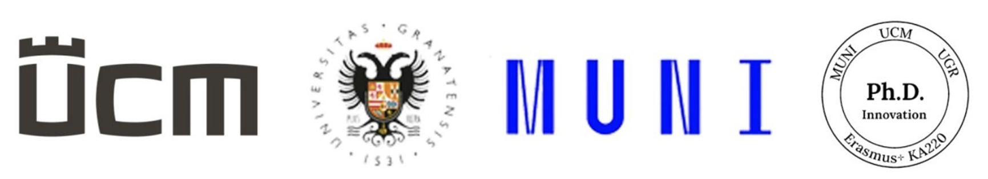

**Department of Russian Studies, Faculty of Arts, University of Ss. Cyril and Methodius in Trnava,**

**Institute of Slavonic Studies, Faculty of Arts, Masaryk University in Brno,**

**Department of Greek and Slavic Philology, Faculty of Arts,   
University of Granada**

cordially invite you to the

**International Academic Conference for Students and Educators**

**of Doctoral Study Programs,**

**which will take place on January 29, 2025, in Trnava.**

The conference will take place at the Faculty of Arts of the University of Ss. Cyril and Methodius in Trnava as part of the Erasmus+ grant project no. 2021-1-SK01-KA220-HED-000022917, titled *The Innovation of the Concept and Curriculum of Doctoral Study Programs and Increasing Their Effectiveness*. It is primarily intended for students and educators involved in doctoral studies at Slovak and international departments and institutes of Russian and Slavic studies. Participation is also welcomed from final-year master’s students, who may present the topics and objectives of their theses.

**The main aim of the conference is to present the topics, objectives, structure, and methodology of designing and developing dissertation projects by doctoral students in Russian and Slavic studies at institutions in Slavic and non-Slavic countries, as well as to highlight the contributions of their research.**

**Conference languages:** English, Russian.

**Duration of presentation:** 10 minutes.

**Conference format:** hybrid (combination of in-person and online participation).

Active participation is **free** for all participants. While in-person attendance is preferred, it will also be possible to join the conference online.

Please submit your application for the conference, including the title of your presentation and a resume (in English or Russian) of up to 200 characters, in .doc/.rtf format to the email address [konferenciaphd@gmail.com](mailto:konferenciaphd@gmail.com) **by** **January 10, 2025** (see application form below).

The conference aims to serve as a platform for establishing connections between doctoral students and their educators from universities around the world and for exchanging knowledge related to their research topics. Therefore, the publication of a conference proceedings is not planned.

*All important information about the conference (conference program, starting time, etc.) will be provided by the organizers after January 10, 2025.*

We look forward to meeting you.

Assoc. Prof. PhDr. Andrea Grominová, PhD.

Head of the Organizing Committee of the Conference

and Project Coordinator



**Department of Russian Studies, Faculty of Arts,   
University of Ss. Cyril and Methodius in Trnava,**

**Institute of Slavonic Studies, Faculty of Arts, Masaryk University in Brno,**

**Department of Greek and Slavic Philology, Faculty of Arts,   
University of Granada**

**APPLICATION**

**for the International Academic Conference for Students and Educators**

**of Doctoral Study Programs**

*January 29, 2025, Faculty of Arts, University of Ss. Cyril and Methodius in Trnava,*

*J. Herdu Square 2, 917 01 Trnava*

*(Please send applications exclusively in electronic format, either .doc or .rtf)*

|  |  |
| --- | --- |
| *First Name, Last Name, Academic Titles* |  |
| *Department/Institute* |  |
| *University* |  |
| *University Address* |  |
| *Email Address* |  |
| *Title of Presentation* |  |
| *Resume in English or Russian (max. 200 characters):* |  |